EXCHANGE RATES
Pearson Edexcel - Tuesday 11 June 2019 - Paper 3 (Calculator) Foundation Tier

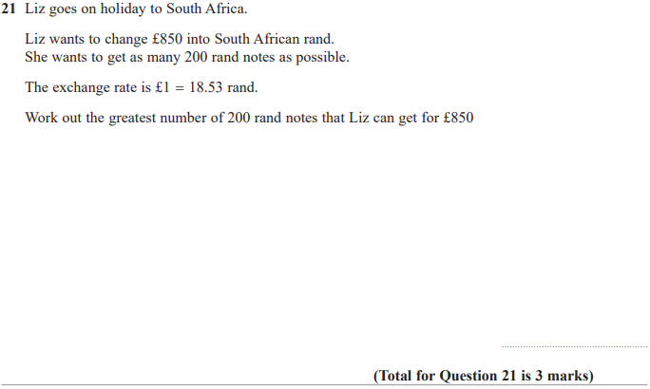

Pearson Edexcel – Specimen 1 - Paper 2 (Calculator) Foundation Tier

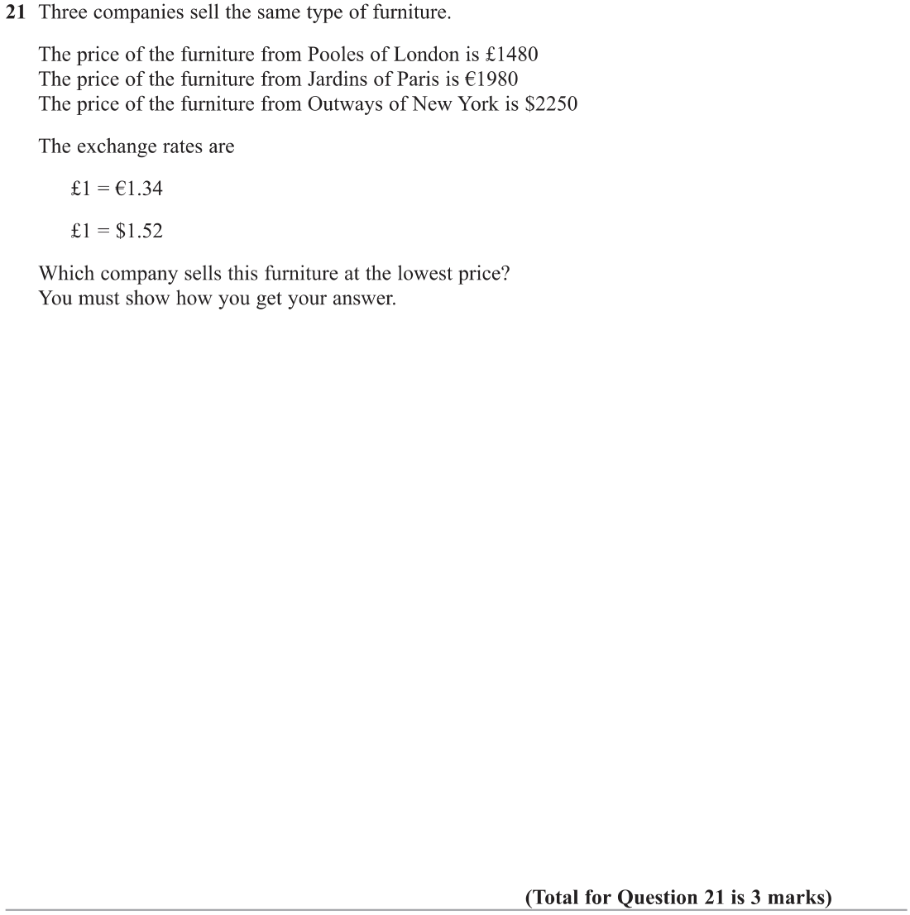

OCR November 09 November 2020- Morning (Calculator) Foundation Tier

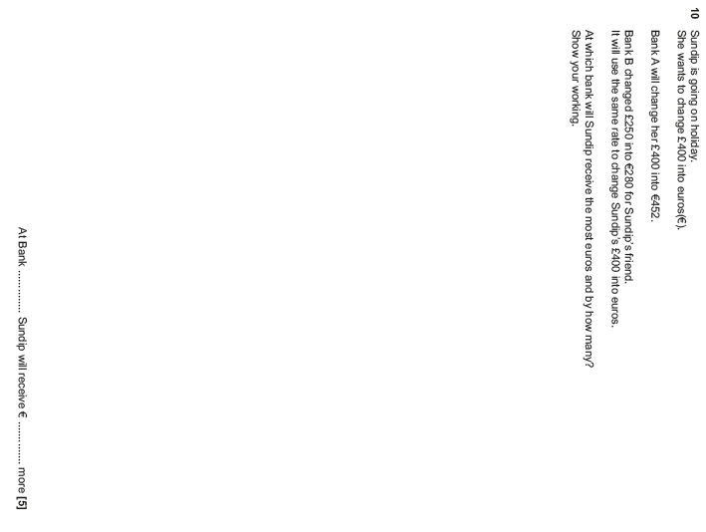

OCR Tuesday 6 November 2018 – Morning (Calculator) Foundation Tier
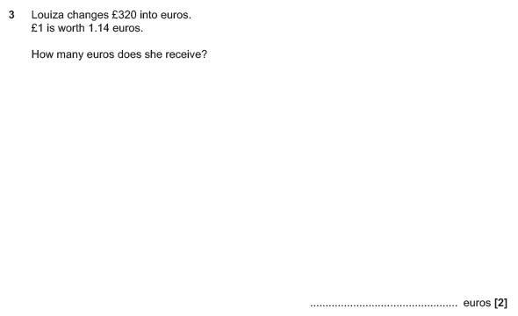

OCR Monday 6 November 2017– Morning (Calculator) Foundation Tier

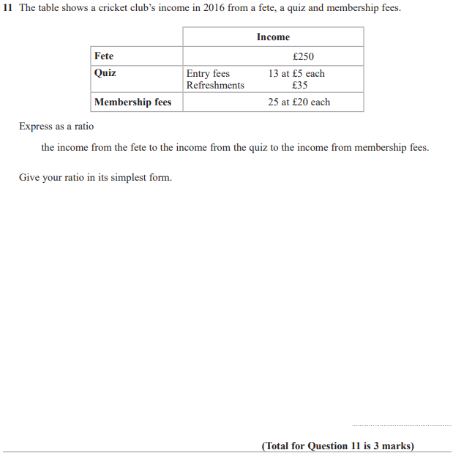

Pearson Edexcel – Sample Papers - Paper 3 (Calculator) Foundation Tier

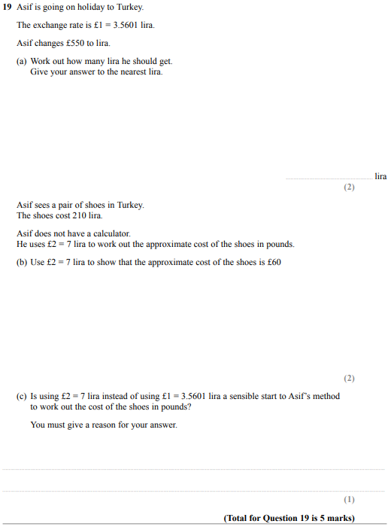

OCR Tuesday 13 June 2017 – Morning (Calculator) Foundation Tier

